Contact

**Address:**

Kharghar, Sector-15,A-15/6, Navi Mumbai-410210.

**Phone:**

+8291215948

**Email:**

[Akshaypawar2505@gmail.com](mailto:Akshaypawar2505@gmail.com)

PERSONAL DETALIS

**Date Of birth:**

25-May-2000

**Marital Status:**

Single

Languages

### English

### Hindi

### Marathi

Hobbies

# watching Movies

# Playing Cricket

# Investing

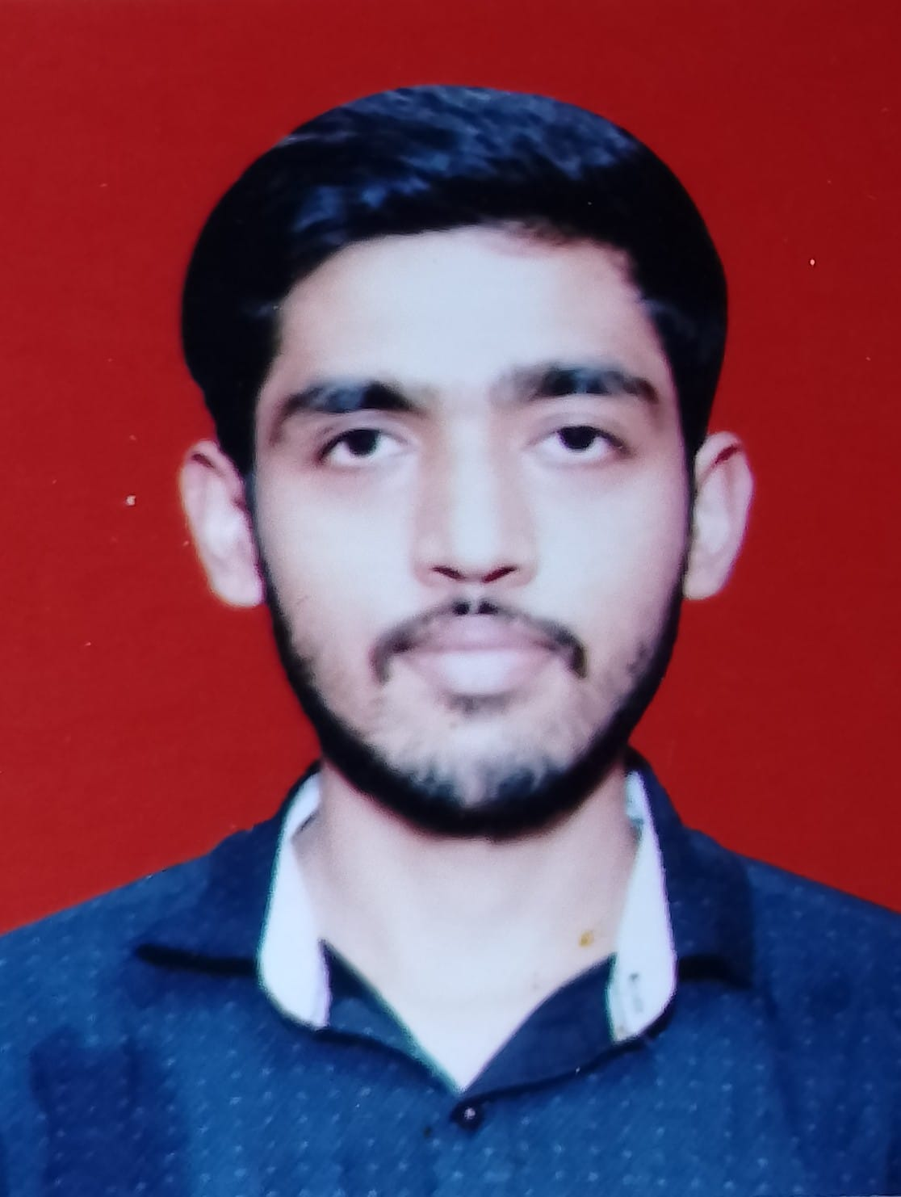

PAWAR

AKSHAY

Objective

Detail-oriented, experienced and highly motivated professional seeking the position of Accounts Receivable in 'Escon Elevator' to use my vast knowledge and strong background for maintaining accurate records of financial operations, and timely payment collection.

Skill Highlights

|  |  |
| --- | --- |
| * Advance Excel * Ms. Office | * Tally Prime |
|  |  |

Experience

**Account Executive** – **15/08/2020 to 27/10/2022**

**Bhavna Autoweels Pvt Ltd**, **Navi Mumbai.**

* Handling of accounts on TALLY ERP
* Making Entry of Sale, Purchase, Payment, Receipts in Tally..
* Handling Cash & Petty Cash.

Vendor Related Payables-

* Book vendor bills and check for supporting documents
* Ensure that utility bills are cleared within the due dates
* Process payments based on Management approval
* Check the expenses entries booked at Branches and ensure supporting documents are adequate

**Account Receivable- 13/11/2022 to Present**

**Escon Elevators Pvt Ltd, Navi Mumbai.**

* Generate Tax Invoice & Proforma Invoice .
* Preparation of E-Invoice.
* Preparation of Advance Billing of Pvt/Govt Client .
* Co-ordinate with sales team for suspense entry payment.
* Weekly Outstanding Statement
* Daily Collections Report
* Check the agreement and ensure the terms are accurate
* Ensure all documents and records are properly filed

**Education**

HIGHER SECONDARY CERTIFICATE

H.S.C Commerce in India 2017

SECONDARY SCHOOL CERTIFICATE

BHARATI VIDYAPEETH SCHOOL, India 2015

**Additional Qualifications**

Bachelor of Business Administration: **Finance 2020**, D.Y.Patil University, Navi Mumbai.