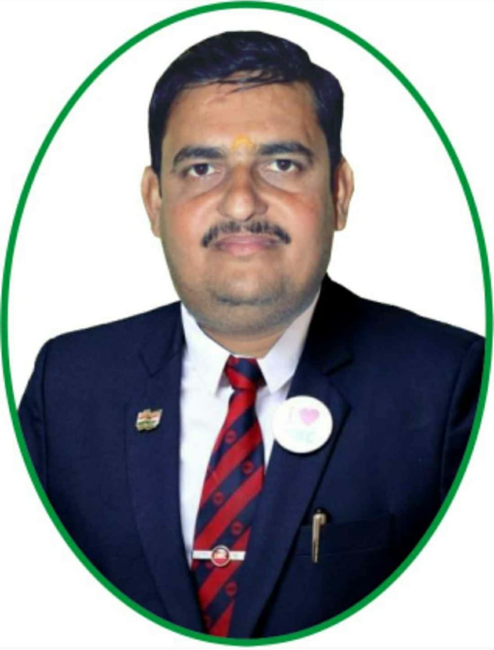
Sandeep S Pandey

EMAIL: rockings220@rediffmail.com/rockings220@gmail.com

CAREER OBJECTIVE

Seeking assignments in the areas of Service Operations/ Client servicing in a growth-oriented organization, hardworking & sincere

PROFESSIONAL SUMMARY

- Over than 14 years of experience in handling responsible job for customer support services via programming customizations, corrections, and enhancements for the clients.
- Service Operations, Documentation, Client Servicing, Relationship Management and Team Management in reputed companies.
- Proficient at maintaining cordial relationship with customers, ensuring quality and service norms to achieve customer satisfaction and business retention.

ORGANIZATIONAL EXPERIENCE

Name of the Company : Hardev Health Care LLP.
Designation : Business Development Manager
Duration : From 1st Dec. 2022 to Till Date

A) Major Responsibilities:
- Engaged in sales Activity for Health Service in Industrial & Corporate .
- Meetings with EHS & HRD for generate Order.
- Strategies and plans for achieving the target.

B) Geographical Area:
- Whole Maharashtra & Gujrat.

Name of the Company : Eureka Forbes (Aarna Enterprises)
Designation : Service Management
Duration : From June 2020 to 30th Dec. 2022

A) Major Responsibilities :
- Engaged in sales of AMC & New Unit.
- Engaged in Service.
- Strategies and plans for achieving the target.

B) Geographical Area :
- Thane Maharashtra

Name of the Company : Emcure Pharmaceuticals Pvt.Ltd.
Designation : Business Manager
Duration : From Jan 2010 to Feb.2020

A) Major Responsibilities:
Name of the Company : Emcure Pharmaceuticals Pvt.Ltd.
Designation : Business Manager
Duration : From Jan 2010 to Feb.2020

A) Major Responsibilities:
- Engaged in sales Activity for Wired line (Broadband & WIMAX) service booking.
As well as customer service and collection of bill amount.
- With technical team survey done for potential area for deploying of fiber optic Cable.
- Strategies and plans for achieving the target.

B) Geographical Area:
- Business Growth
- With team visit Infront of Doctor’s.
- Strategies and plans for achieving the target.

B) Geographical Area:
- Whole Thane

SKILL SET

➢ Attention to detail and strong problem-solving skills
➢ Ability to perform presentations in a client setting
➢ Ability to understand written and verbal communication
➢ Ability to work as part of a team to get resolution to client issues
➢ Communicate effectively with both internal and external customers
➢ Present a professional image to the customer
➢ Manage time and set priorities for tasks
➢ Understand the functionality of software applications, in context of client usage
➢ Practice effective self-management
➢ Support aptitude

DUTIES AND RESPONSIBILITIES

➢ Responsible for providing technical support coverage during hours assigned
➢ Program corrections/enhancements to the product lines
➢ Provide patches to clients as appropriate
➢ Provide updates on all in Client Database
➢ Verify customer issues in the product lines
➢ Provide a knowledge base to internal and external customers on product lines
➢ Provide accurate problem descriptions, with all necessary support documentation for
Interdepartmental smartly of client issues.
➢ Escalate issues as needed to Application Support Manager
➢ Work as a team to meet contractual support requirements
➢ Have good cross department communication and relationships.
➢ Provide resolution of support issues by having a strong understanding of an Application
➢ Assist in the retention of support contracts by offering superior customer support experience
➢ Assist in the education of clients on an application suite
➢ Handle other duties as assigned.

EDUCATIONAL QUALIFICATION

◆ School Secondary Certificate
Grade: 2nd / University: UP Board

◆ Higher Secondary Certificate
Grade: 2nd / Stream: Arts / University: UP Board

◆ Graduation
Grade: 2nd / Stream: Arts / University: VBS Poorvanchal University

PERSONAL DETAILS

Phone: 91+ 9670963333/9594701688

◆ Address: -
333, Vinayak Bhavan, Kolbad Road, Thane West, MH-400601

Date of Birth: 15 / 08 / 1987

Sex : Male

Marital Status : married

Nationality : Indian

Languages Known: English & Hindi

