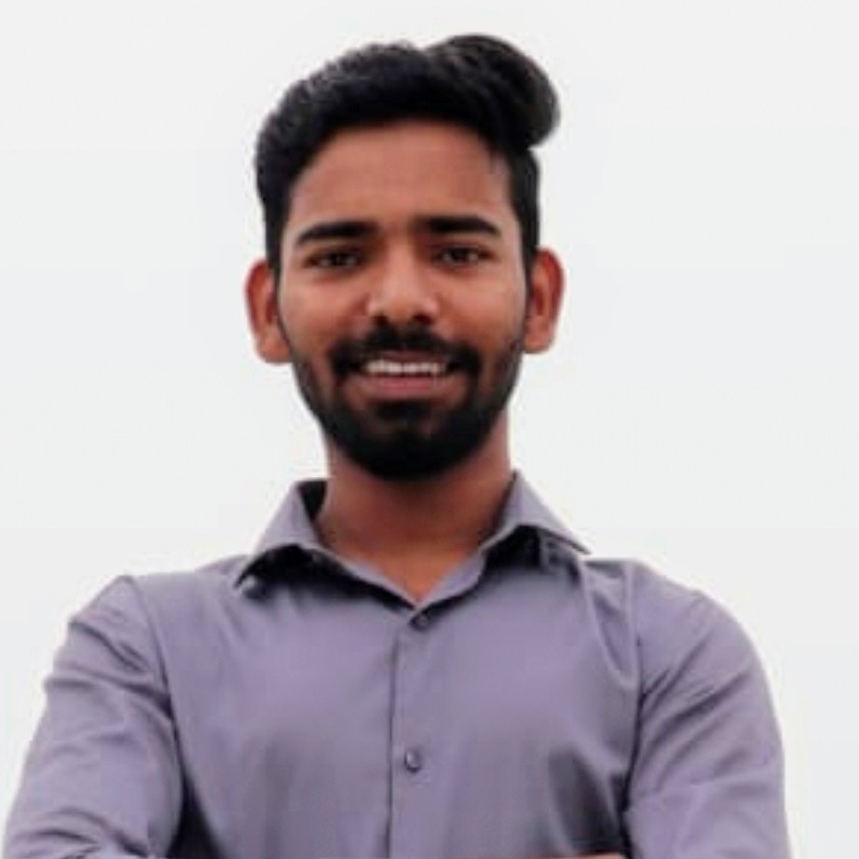 RESUME

SATISH VISHWAS SONAWANE

A/P Patas, Tal- Daund , Dist - Pune, Pune, India

D.O.B : 07/09/1998

Marital Status : Single

Email : ssonawane053@gmail.com

Mobile: 9834751465

# OBJECTIVE

Willing to work in atmosphere which will help me to explore myself fully and realize my potential to continiously upgrade and aquire knowledge and skills to effectively use in an industry.

# EDUCATION

|  |  |  |  |
| --- | --- | --- | --- |
| Degree/Course | institute | Year of Passing | Percentage / Grade |
| BE MECHANICAL | SVPM'S COE Malegoan BK | 2020 | 59.78 |
| DME | DATTAKALA POLYTECHNIC | 2017 | 75.41 |
| SSC | Nageshwar Vidyalay Patas | 2014 | 81 |

|  |  |
| --- | --- |
| PROJECTS |  |
| Title | Automatic Hand Braking and releasing sys |
| Description : | Our project is on automation basis which where overcomes the problem occur to park heavy duty vehicles in different areas.. Hand brake get automatically activate when we turn off the engine switch. |
| Duration : | 1 Year |
| Role : | Project member. |
| Team Size : | 4 |
| Title | NCHS & Wastage heat Utilisation. |
| Description : | Multiple uses of butane gas in domestic gas cylinder. |
| Duration : | 1 |
| Role : | Project member |
| Team Size : | 4 |
| LANGUAGES | |

Marathi, Hindi, English

INTERESTS

Quality, Maintenance, Production.

SKILLS

AUTOCAD, CATIA , SOLID MODELLING, MATLAB

HOBBIES

Painting, Playing Volleyball, Playing Harmonium, Traveling.

# DECLARATION

I hereby declare that the above mentioned information is correct upto my knowledge and bear too responsibility for the correctness of above mentioned particulars.

Date:

Place:

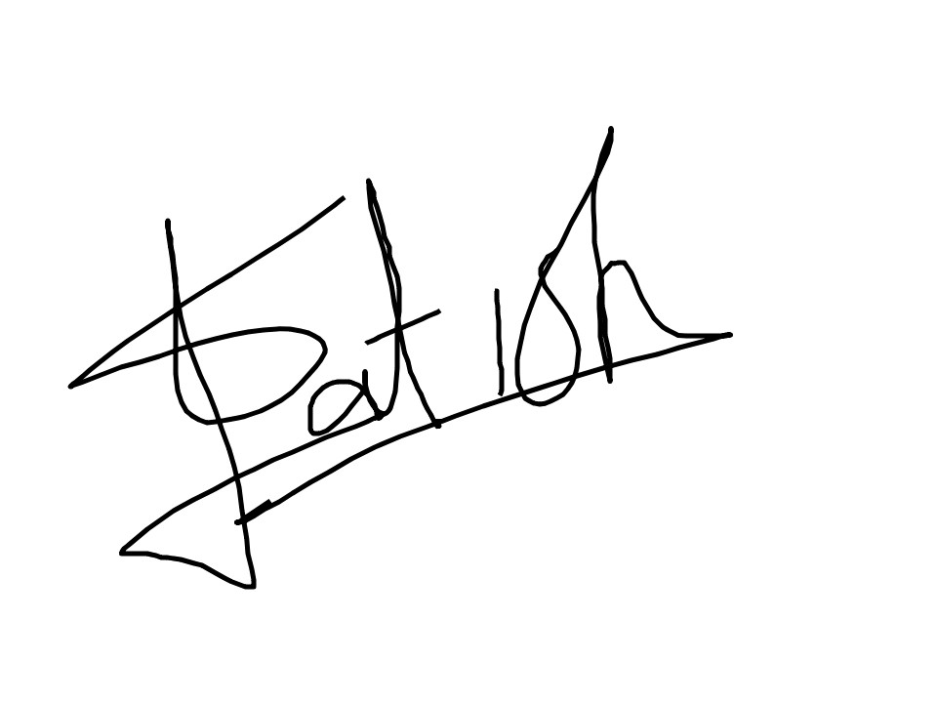

(Satish Vishwas Sonawane)