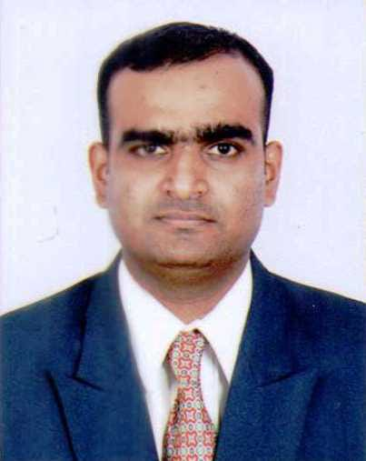

**Pol Harshad Ashokrao**

A-12/45, Sector-2,

CBD Belapur,

Navi Mumbai, Contact No.:- 9920369538

PIN – 400614 Email ID:- harshadpol1234@gmail.com

***Career Objective***

Seeking a position to utilize my skills and abilities in the Industry that offers Professional growth while being resourceful, innovative and flexible.

***Professional Experience***

**JLL** as **Duty Manager** From 27th Dec, 2018 till 31st Aug 2020.

Duty Manager, Facilities will be responsible for managing all aspects of day to day service delivery in Accenture during the shift. And also will be accountable for proper usage and functionality of the technologies implement at site.

Responsibilities: Helpdesk/Mailroom Operations, Front Office Operations,Security Operations, Housekeeping Operations, Cafeteria Operations, General Operations

**YMT** as **Clerk** From 7th Dec, 2017 till 30th Sep, 2018

Assisting in Marketing activities of Ayurvedic Mediclaim Policy & admissions in MMS Course,

Involving in Medical Camp in rural remote area. Looking after scholarship process of Govt.

**Louis Philippe** as **CCA** From 21th Mar, 2017 t0 6th Dec, 2017

Sales target and achievement, cashiering, analyzing data, control inventory loss, tracking customers

**Vijay Sales** as **Team Leader** Duration 20th April, 2014 to 9th April, 2015

To handle IT section. Arrangement of stock from go-down and other nearest store. To handle team of staff members and brand staff. Making display merchandising.Offer tags and promotions of season sale.

**Reliance Digital Express** as **Solution Executive** Duration 25th May, 2013 to 20th Jan, 2014

Providing solution selling with the help of connectivity POD's. By understanding the requirement closing sale.With proper probing questions used to understand the requirement.

**Reliance Digital Express Mini** as **Store Leader** Duration 21st Jan, 2014 to 18th Mar, 2014

Handling of Day to day Store Activities like opening the store,maintaning registers,stock in stock out process using SAP. As well being vigilant providing the security loss & prevention work.

**Educational Profile**

* Completed Post Graduation in “**MBA (Retail Management)”** from DYPDBM from Padmashree Dr. D. Y. Patil University, CBD Belapur with **First Class** in **April 2013**.
* Completed Graduation in “***B.Sc Information Technology”*** from SIES(Nerul) College of Arts, Science and Commerce, Nerul with  **56.39%** Marks in **March 2011**.
* Passed HSC from Bharati Vidyapeeth Prashala & Jr. College, CBD Belapur with **59.17 %** Marks in **February 2007**.
* Passed SSC from Bharati Vidyapeeth Prashala & Jr. College, CBD Belapur with **80.13 %** Marks in **March 2005**.

***Computer Proficiency***

Languages : C, C++, C#, SQL, Core Java, Advanced Java ,VB 6.0, XML, ASP .NET, ADO.NET, SAP.

Platforms : Windows XP, Windows Vista, Windows 7, Windows 8.

Other skills : MS office(2003, 2007 & 2010) Master in MS Advance Excel: V look up , H look up, Pivot Table ,Graphs ,Text to Excel, Sorting, Macro, Formatting, etc.

**Extra Curricular Activities**

Organized 4th International Research Conference on Retail, “IRCR 2011: Solutions for Better Retailing” held in 12th November 2011 at DYPDBM.

Successfully completed a **6 days Project** in **Future Value Retail Limited** during **“Big Days”** with **Food Bazaar Lokhandwala** from 24th January, 2012 to 29th January, 2012.

Successfully Completed **Summer Internship Project** in Retail Operations at **Staples Future Office Products Pvt. Ltd**., has worked from 3rd May, 2012 to 30th June, 2012.

**Microsoft Office Proficiency**

Successfully Completed **MS-CIT** with **76 %** marks in the month of **July-2005** from **MKCL** & **MSBTE**.

Successfully Completed **Computer Fundamental, MS Word, MS Excel, MS PowerPoint, Internet** from **APTECH** Computer Education on **14th April, 2006**.

Successfully Completed **Demonstrated Product Knowledge** and **Sales expertise** to achieve **PC Aisle Accreditation** of **Microsoft** on **29th Nov, 2014.**

***Project Work Undertaken Post Graduation***

My topic for the study is on “Consumer Buying Behavior about pens”. Pen is a product, which is used by each and every person. There are various brands of pen in the market of different types Price, Color, design, Grip etc .so the pen market is full of competition where the consumer possesses vast variety of choice to select his brand which depends on his buying Behavior.

***Project Work Undertaken For Graduation***

Developed a SURVELLIANCE SYSTEM for Siddhivinayak Recruitsoft Consultancy private limited, the seven years old organization focusing on Training in Advance Software technologies, Software Development and IT Recruitment. Survelliance System will secretly record all computer related activities and present thus to information to you through detailed and precise reports that will reveal exactly what has been happening on your computer.

***Personal Profile***

Father’s Name : Ashokrao Dharmu Pol

Mother’s Name : Kamal Ashokrao Pol

Sex : Male

Marital status : Married

Date of Birth : 05-07-1989

Nationality : Indian

Religion : Hindu

Languages Known : English, Hindi, Sanskrit and Marathi.

Mother Tongue : Marathi

**Declaration:**

I hereby declare that the above written particulars are true to the best of my knowledge and confidence.

Place:

Date: (Pol Harshad Ashokrao)