**Resume** 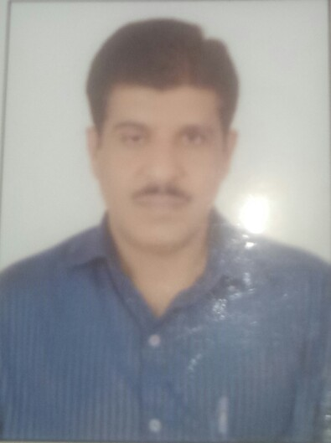

**Resume Title**

Seeking better platform to render services as per best of my abilities & work experience.

Contact Information

|  |  |
| --- | --- |
| **Shailesh Ratanlal Bhatia**  **403, Sai Angan, Plot No. 145/146, Sector 1E, Near Kalamboli Police Station, Kalamboli. Navi Mumbai :** | [Email :](mailto:) [shaileshbhatia.2009@rediffmail.com](mailto:shaileshbhatia.2009@rediffmail.com)  **Cell phone- 09004293019, 7977022909**  **Current Location: Kalamboli, Navi Mumbai.** |

**Personal Information**

**Date of Birth :  31 October 1968**

**Gender :   Male  
Nationality :   India**

**Highest Qualification – M.COM (PUNE UNIVERSITY)**

Professional Details:   
Domain Knowledge**-**

**Key points**: Handle factory operations independently, large experience in factory administration with statutory compliances (Factory license, MPCB, Labour license, Boiler inspection etc) Leading Accounts, Purchase, stores, dispatch and Production department.

**About work experience –**

1. Working with **M/s King Metal Works, Mumbai** as Manager – Administration, working since 28.03.2019. M/s King Metal Works is well known utensils manufacturers and exporter, having multiple units in Marol, Andheri and Vasai. Main job roll is office and factory administration, RM procurement, statutory compliances, facility management as like AMC for office equipment, machinery, reporting to Directors.
2. Worked with **M/s. Beardsell Limited** (Navi Mumbai) as Manager-Administration from July’2011 to May 2018, handled entire factory operations with procurement, reporting authority – General Manager (Operation),M/s Beardsell Limited is one of the well-known co. in Thermocol, Rigid Polyurethane Insulation material & Sandwich Panels , eco-friendly Quick Build Panels, PUF sheets & insulation material.
3. **M/s Nandan Petrochem Limited, Taloja** as Plant Manager from August’10 to June’11. Main job responsibilities – Factory administration, procurement, statutory compliances and production planning,
4. M/s **West Coast Lubricants and asphalts Pvt. Ltd.** (**working for MNC’s i.e. Castrol, Shell, BPCL & SPL**) from June 2009 to July’10 as Plant Manager, main job responsibilities, production planning with factory administration, co-ordinate with principal companies.
5. M/s **Nandan Petrochem Ltd. Taloja,** As a Plant Manager from August 2007 to May 2009.
6. **M/s G.K. Tempo, Jalgaon (Authorized dealer for Force Motors Ltd)** As Works Manager from November 1988 to July 2007, leading to accounts, store and spares, entire responsibility of sales after service, customer satisfaction, co-ordination with Insurance companies for vehicle accident claims. Manage spare parts inventory, co-ordination with principal company for spare and warranty claim settlement.

**Strengths**

* Hard work and quick understating, timely decision.
* Good team leader
* Best Performance under work pressure.
* Ready to accept challenges.

**Computer knowledge**:

* Windows
* Ms-office
* Well versed with online software as Like SAP, ERP and Tally.