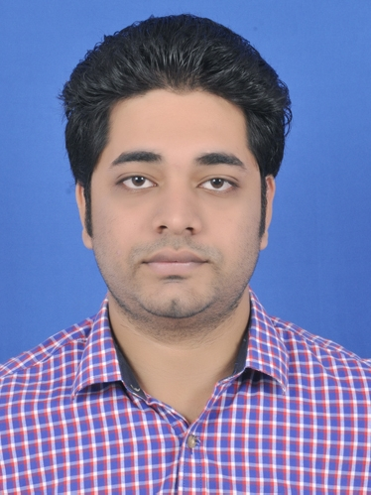 |  | DEVEN KASHINATH WAJEKAR  PHONE: (Mob)+91-8369460743 (Res) +91-9930093847  Email id: rildevenwajekar@gmail.com  WEBSITE: https://www.linkedin.com/in/deven-wajekar-a97927136/
CAREER OBJECTIVE  Evolve as a full-fledged Electronics Engineer with strong computer knowledge, skills and experience and be part of a dynamic organization that encourages mutual growth, continuous learning and team play.  THE SKILLS  Believe in hard work and patience, Strong willingness to learn new skills and abilities, A good team player, Has the ability to create a healthy atmosphere in work environment, Quick decision-making ability.  HOBBIES  Listening to music  Watching TV  Playing Cricket  Travelling  Reading books  LANGUAGE KNOWNS  English.  Hindi.  Marathi.  CRETIFICATED COURCE  1.Advance Diploma in Embedded System in IDEMI Technical institute Mumbai  2. Java Technology in Profound Edutech  INTRESTED WORKING AREA  1.Production Planning  2.Supply Chain Management  3.Electrical Maintenance  4.Purchase management  5.Quality Engineer  6.Operation Engineer |  | EDUCATION  Pursing 2019  MBA: ITM Executive Education Navi Mumbai  PERCENTAGE: 1ST year: 73.25%  Aug2014-Sept2017  BE-ELECTRONICS: Jawahar Education Society’s Anna Saheb Chudaman Patil College of Engineering Navi Mumbai  CGPA: 5.77  June2010-May2014  DIPLOMA: Bharati Vidyapeeth College of Engineering College in Navi Mumbai  PERCENTAGE: 66.57%  SSC: K. A. Banthia High School New Panvel  PERCENTAGE: 67.45%  INTERNSHIP  SUMMER INTERNSHIP:  COMPANY NAME: Reliance Industries Limited (CES-ELECTRICAL/PSF Plant): It was there 1-month internship program where I was trained in UPS PLC and Drives system technical as well as practical knowledge and combine all three module one small project making helped by Mr. Tarun Goeal Sir.  COMPANY NAME: Cipla Limited  It was there 1.5-month internship program where I was trained in Supply chain and Logistic department to handling a product and packing of product all topics are, I will be small making report and that report help with me a Cipla packing department Manager and Engineers will be help me  SKILLS  - Adjustable  - Creative  - Microsoft Office  - Quick Learner  - Problem Solving  - Teamwork  - Writing  - Time Management  - Self-motivated

TECHNICAL PROFICIENCIES
Operating System: MS DOS, Windows 95/98/2000/xp/9/10
Programing Language: Embedded System, C, Java, HTML,CSS

EXTRA CURRICULAR ACTIVITIES
- Member of ABHIYAN committee during 2014
- Spectrum Committee during 2014
- Event organiser during college technical fest.
- Participated in Avishkar Research Convocation.

ACADEMIC PROJECTS
BACHELOR OF ELECTRONICS ENGINEERING PROJECT:
NAME OF PROJECT:
- Vehicle Control System Implantation Using Can Protocol: It is CAN controller ARM based project
I. In system will be used ARM controller and that data Transfer to the CAN Module and display the result
II. There are used in Motor Vehicles all function shown in dashboard.
- 4*4*4 Arduino controlled Led Cube: It is a simple Decoration purpose mini project making in college
Using Arduino module.
3. Low Cost Metal Detector: It is making a one copper coiled connect to ic555 and detected metals objects

DIPLOMA PROJECT:
NAME OF PROJECT:
- Finger Print Based Home Security Using Microcontroller: It is a microprocessor 8085 based project
I. In there are one mechanical door and Attached a sensor of finger print module if valid data transfer the door opening automatically otherwise wrong data get found it so start the alarm

PERSONAL DETAILS

Date of Birth | 13 AUG 1994
Sex | Male
Nationality | Indian.
Passport | Yes Available
Address: | Ganga Dham D 103 Bldg. no:01 Gat:4 Hissa:3 Pali Devad Sukapur New Panvel

Date:
Place:
Deven Kashinath Wajekar

