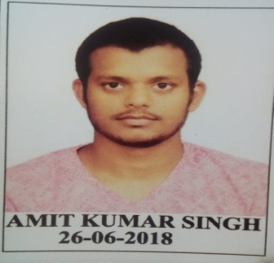**AMIT KUMAR SINGH**

Address: Vill+Post - Pali, Dist-Gorakhpur,273209

E-mail id- [basgns1996@gmail.com](mailto:basgns1996@gmail.com)

Mobile: +919807179769

**CAREER OBJECTIVE**

To be involved in work where I can utilize skill and creatively involved with system That effectively contributes to the growth of organization.

**ACADEMICS**

|  |  |  |  |  |
| --- | --- | --- | --- | --- |
| EXAM PASSED | COLLEGE/SCHOOL | BOARD/UNIVERSITY | PERCENTAGE OBTAINED | YEAR OF PASSING |
| 10th | BABA RAM AMRIT DAS INTER COLLEGE JOGIYAPALI SAHJANWA | UP BOARD | 47.83 | 2010 |
| 12th | BABU RAM SINGH JANTA INTER COLLEGE MAJHAUA JAGAT BASTI | UP BOARD | 56.2 | 2012 |
| B.SC | NANDINI NAGAR PG COLLEGE | DR. RAM MANOHAR LOHIYA AWADH UNIVERSITY | 54.88 | 2015 |
| ITI | SARVODAY PVT. ITI | ITI NCVT | 82.11 | 2018 |

**SPECILIZATION**

* CCC Qualified from NIELIET.
* TALLY ERP9.

**SKILL**

* MS WORLD
* MS OFFICE
* POWER POINT

**PERSONAL DETAILS**

**Name**  : Amit Kumar Singh

**Father’s Name**  : Mr. Suresh Chand Singh

**Date of Birth**  : 1st January, 1996

**Nationality.** : Indian

**Permanent Address.**  : Address:Vill+Post-Pali,Thana-Sahjanwa Dist-

Gorakhpur (273209)

**DECLARATION**

I hereby, declare that the above details are true to the best of my knowledge.

Amit Kumar Singh

Place: Gorakhpur

Date: 28th June, 2019