CURRICULUM VITAE

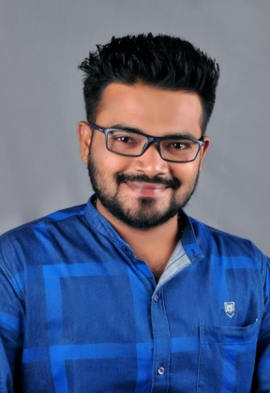

**Sanket Anil Pingale**

**Mangaon,Dist-Raigard**

**Ph.-+91 8983705991**

**Email-sanketpingale2017@gmail.com**

**OBJECTIVE:**

To be associated with a progressive organization that gives me scope to update my knowledge and skills in accordance with latest trends and to be a part of team that dynamically works towards the growth of the organization and gain satisfaction thereof.

EDUCATIONAL QUALIFICATION:

* Bachelor in science(Chemistry) from Mumbai College
* Intermediate from Mumbai college(Feb 2008)
* HSC From Mumbai School(March 2006)

**Industrial Experiences:**

1. **Company Name: Earth Water Technologies**

* **Job Area: Dombivilli**
* **Duration**: 1st May 2015 to 1 june 2016
* **Designation**: Service Engineer-Water Treatment plants& worked as a Plant Supervisor.

**Job Responsibility:**

* Servicing of WTP RO plant
* Managing all kinds of operation & maintenance document of the WWTP, RO, in the at o&m site
* Implement of Quality System RO Plant
* Erection and commissioning of ro plants MGF(Multigrade filter),ACF(Activated Carbon Filter)
* Inspect the treatment plant systems on a daily basis to ensure effective operations
* Conduct regular inspections of the physical plant
* Establish preventative maintenance schedules
* Maintain inventories
* Provide reports to Site Manager,
* Ensure records are maintained
* Operating RO plant having 10m3 and Handling all type of troubleshooting which is required for RO plant such as membrane replacement, probing, and RO cleaning.
* Maintain Documentation daily log sheet.
* Dealing with issues related to Quality.
* Maintenance of History Records of all the equipment’s
* Handling all types of in-house testing’s parameter checking and maintaining the records up to date.
* Preparing log book and stock report. Preparing log book and stock report.

**Technical Purview:**

* RO PLANT
* SOFTNER
* MGF
* ACF

PERSONAL STRENGTH:

* Self-starter.
* Diligent and smart worker.
* Sincere and committed.
* Results by planned approach and logical thinking.
* Team player.
* Good communication skill.
* Self-motive and self-confidence.
* Ability to work in shift.

TECHNICAL PROFICIENCY:

OS : Windows 98/2000/XP, MS-Office

**LANGUAGE KNOWN: - MARATHI, HINDI, ENGLISH**

DECLARATION:

I hereby declare that all the above information furnished above one true in my best of my knowledge.

PERSONAL DETIALS:-

* NAME:- SANKET ANIL PINGALE
* DOB:- 08/10/1990
* FATHER NAME:- ANIL BABURAV PINGALE
* ADDRESS:- Addrash samata nagar mangaon Raigad 402104
* MOBILE NUMBER:- 8983705991
* EMAIL ID:- sanketpingale2017@gmail.com

THANK YOU

SANKET ANIL PINGALE