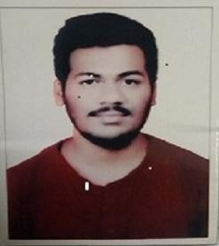**Vedant Baliram Gharat-B.E (Mechanical)**

Phone no - (+91)7507375592

Email Id- [vgharat11@gmail.com](mailto:Kondilkaranish@gmail.com)

Zeal College of Engineering & Research Pune ,411041



* **Career Objective**

To work hard with dedication and to contribute best for the growth of the organization.

# Educational Qualification

|  |  |  |  |
| --- | --- | --- | --- |
| **Examination** | **Board/University** | **Year of Passing** | **CGPA/** **Obtained** |
| BE | SPPU | 2018 | 65 |
| HSC | Maharashtra Board | 2014 | 64.46 |
| SSC | Maharashtra Board | 2012 | 73.60 |

* **Academic Project**

Project Name – Performance Analysis of Solar Collector with Inline and Perforated W Shape Rib Roughened Absorber Plate.

Description: “The Objective of this Project is to Find Temperature Difference of Solar Collector with Inline and Perforated W-Shape Rib Roughened Absorber Plate. This is used for Space Heating and Drying Purpose

# Awards and Achievements

* + District Level Hockey Player

# Areas of Personal Interests

* + Playing Football.
  + Listening Music
  + Dancing

# Personal Details

* + Fathers Name – Baliram Ramdas Gharat
  + Mothers Name – Sandhya Baliram Gharat
  + Date of Birth – 24 November 1996
  + Marital Status- Unmarried
  + Address – Savli Niwas Chambharli Mohopada Rasayani Tal:Khalapur,Dis:Raigad 410222

# Declaration

I hereby declare that all the information mentioned above is true to the best of my knowledge.

Vedant. B. Gharat