Curriculum Vitae
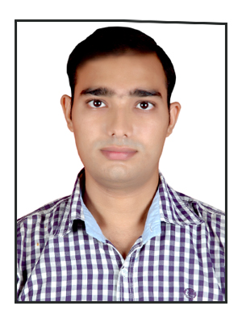

ANOOP DUBEY

Email : 18anoop09@gmail.com
Contact no : +91-9887981337
: +91-9785107590

CAREER OBJECTIVE
To work for a progressive organization in a highly motivating and challenging environment that provides the best opportunities to grow and utilize my potential to the fullest to achieve the organization’s goal while achieving my personal goals and to contribute whole heartedly towards the development of the organization and grow while performing.

ACADEMIC QUALIFICATIONS
EXAM / DEGREE | YEAR | UNIVERSITY / BOARD | PERCENTAGE
B.Tech. (MECHANICAL ENGINEERING) | 2015 | Rajasthan Technical University | 71.98%
12th Board | 2011 | CBSE | 64.80%
10th Board | 2009 | CBSE | 73.00%

PROJECT DETAILS
Project Title | PNEUMATIC HACHSAW CUTTER
Platform | Automatic
Team Size | 05
Role Played | Team leader
Description | Used for production process as it is more economical due to the use of compressed air as a main source for energy supply to the machine for working

EXPERIENCE
COMPANY | PERIOD | TYPE
Ultratech Cement Limited Adityapuram | 6months & 8 days | On contractor basis I have been worked there as a supervisor and manpower handling.  Basics of coal mill and raw mill.
IIM Ahmedabad | From Dec 2015 till Oct 2016 | On contractor basis as a trainee
Urja Gasifier Pvt. Ltd.  Gorakhpur | From Nov 2016 to Jan 2019 | As an engineer and assistant admin

INDUSTRIAL TRAINING & VISIT
Company | Ultratech Cement Limited Adityapuram
Platform | Manufacturing Of Grey Cement
Description | It Is the first Cement Plant to get ISO 9001:2001 certifications in India. It is a unit of Grasim industries Ltd. Of Aditya Birla Group. The cement plant with 1.75 million tonnes per annum capacity was commissioned in a record time in march 1995.
Company | Volkswagon India Private Limited, Chakan, Pune
Company | Chowgule & co. Pvt. Ltd., shipbuilding division, Goa.

PERSONAL SKILLS
- Quality to do work as team player with interpersonal skills.
- Willingness to learn, team facilitator and smart worker.
- Capable of handling problem at different situations.
- I also have leadership qualities.

ACHIEVEMENTS & EXTRA CURRICULAR
- Certificate in AUTO-CADD for designing in 2D.
- Certificate in STADD-PRO for designing in 3D.
- Event organizer in college annual day functions and other technical events.

PERSONAL PROFILE
Name :Anoop Dubey
Father’s name :Shailendra Dubey
Mother’s Name :Pushpa Dubey
Date of Birth :07 August 1992
Permanent Address :Naya Makan Bharauli Gola Gorakhpur 273002
Contact Details :Email:18anoop09@gmail.com
:Ph No:- +919887981337, +919785107590
Nationality :Indian
Gender :male
Marital Status :Unmarried
Hobbies :Listening To Music, playing football, driving
Blood Group :AB positive
Language Known :English, Hindi

Declaration:

I here by declare that above information is correct to the best of my knowledge.

DATE:

PLACE: ANOOP DUBEY

