**KAMAL BHARDWAJ**

Gyan lok colony, Khurja (Bulandshahar), Uttar Pradesh ,

7409406748

[Thinkingultimate@gmail.com](mailto:Thinkingultimate@gmail.com)

**CAREER OBJECTIVE**



To work as a mechanical engineer in an automobile / manufacturing industry where I can upgrade my knowledge and skills.

**EXPERIENCE**



**Makino Auto Industries**



Mechanical Engineer

*May 2015 - Present*

To perform in-process quality inspection.

To ensure achievement of daily and monthly production targets.

To do final inspection as per sampling plan.

To provide pre dispatch inspection reports to customers.

Planning and directing activities related to quality standards and production.

Handling the responsibilities of implementing and monitoring quality and production plans.

**EDUCATION**



**Motilal Nehru National Institute of Technology (MNNIT) Allahabad**



M.tech with 7.5 CGPA

2014

**MIT, Bulandshahar (GBTU)**



B.tech (Mechanical) with 67.38%

2011

**Saraswati Vidya Mandir, Khurja (CBSE)**



SSC with 76.3%

2007

**Saraswati Vidya Mandir, Khurja (CBSE)**



HSC with 79.8%

2005

**TECHNICAL SKILLS**



Knowledge of 7 QC Tools, 5S, Kaizen.



Knowledge of High Pressure Die Casting Process.



Knowledge of Microsoft oﬃce - Word, Excel, Power point.



Total Quality Management.



6 sigma quality control.



ISO 9001:2015 quality management system.



Knowledge of 5 core tools - APQP , FMEA , MSA , PPAP and SPC.



**ACHIEVEMENTS & AWARDS**



GATE 2012 Qualified



**PERSONAL PROFILE**



Date of Birth



Marital Status



Nationality



: 19/10/1990

: Married

: Indian

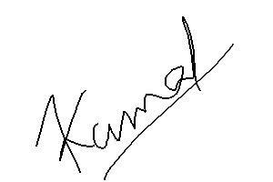

Languages Known : Hindi, english



**KAMAL BHARDWAJ**