**RESUME**

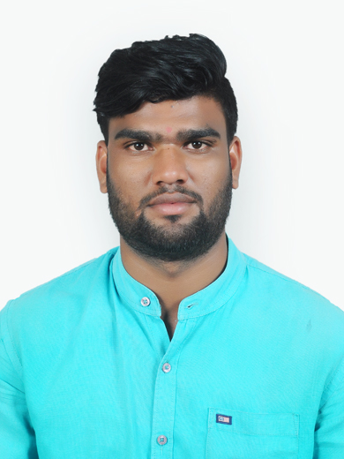

**Ramchandra Lakshaman Zore.** [ramzore31@gmail.com](mailto:priyankabhos8@gmail.com)

Samadhan society, sec-14, kalamboli, New mumbai 410218. +919637556715

**___________________________________________________________________________**

**CAREER OBJECTIVE:**

To secure a job in industry where I can utilize my knowledge for the organization’s growth.

**EDUCATION:**

|  |  |  |  |
| --- | --- | --- | --- |
| **Degree** | **Board** | **Year of passing** | **Percentage** |
| BE*(Mechanical  Engineering) | Savitribai Phule ( Pune) University | 2018 | 80.2% |
| Diploma | Maharashtra State board | 2015 | 70.71% |
| SSC | Maharashtra State board | 2012 | 73.20% |

**SEMINAR:**

**Seminar Title(TE):** Drainage control system in railway wagon.

**PROJECT:**

**Project Title(Diploma):** Agri-cutter.

**Project Title(BE):** XY gantry mechanism for chemical handling application.

**STRENGTHS:**

* Punctual
* Team oriented
* organized

**EXTRA CURRICULAR:**

* Got first prize in photo exhibition(Sub: Public Hygiene)
* Completed training in Hydro-Pneumatic Programmer/ PLC
* Participated in Quiz competition in various national level competitions
* Auto-cad

**HOBBIES:**

* Swimming
* Playing Cricket
* Travelling

**PERSONAL DETAILS:**

|  |  |
| --- | --- |
| **Nationality:** | Indian |
| **Date of Birth:** | 31/01/1996 |
| **Languages Known:** | English, Hindi, Marathi(Mother tongue) |

**DECLARATION:**

I hereby declare that all statements made in this application are true, complete and correct to the best knowledge and belief.

**Ramchandra Zore**