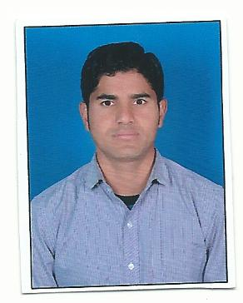

CURRICULUMVITAE
DIGAMBAR SINGH RANA
AsstEngg. (E&M)

Address for correspondence :
Digambar Singh Rana
Village –Ninus P.O.Darmigard Teshil-Tiuni
disstt-Dehradun .Pin-coad -248199
State -Uttarkhand
Mob.No : + 919897956968
Email :Digurana1989@gmail.com

PROFESSIONAL AIM

My professional aim is to make a positive impact in my field of activity, leading to organizational and personal growth by creative application of my value based convictions, job skills and professional dexterity.Have an ability to professionally combine strength in planning, through quality and quantitative analysis to present people with detailed insight.

PROFESSIONAL SUMMARY

Company : | FFT Himalayan Fresh Produce PVT.Ltd
Designation : | Asst. Engineer (Technical E&M and Commercial)
Duration : | Sept-2013 to 31May 2018
Profile : | Responsible for in-proces all electrical and machinecal machines operating testing, routine testing ,servicesing and getting inspection done, with keeping proper records of O2 and CO2 value as well as proper traceablity records. Complete resposiblity of all machines participation and preparation.

EDUCATION AND CREDENTIALS

Year(s) | Qualification – Degree / Diploma / Certificate | Board/University | Percentage / CGPA
2013 | B.tech (EEE) | Uttarakhand Technical University, Dehradun | 62.8%
2008 | XII | Uttarkhand Board | 54.5%

KEY ACCOMPLISHMENTS

Final Year Project
Organization- Shivalik College of Engineering
Duration-6 months
Project Assigned- “Computer aided desing and simulation of axil flux permanent mangnet machine

Summer Training
Organization- UJVNL, Dhalipur power house
Duration-6 weeks (June, 2012-July, 2012)
Topic of Study - Generation and Distribution of Electricity.
WORK EXPERIENCE

Four Years Nine month Experience (4Years 9Month)
Designation : | Asst. Engineer (Technical E&M and Commercial)  250Kw generator service and operate  Greefa Machines-electrical equipment (Sensors, relay, motor )check , oil change , damaje of the part change welding .  Bitzer Compresser operate and handling of lower staff and labure.
Company- FFT Himalayan Fresh Produce PVT.LTD

COMPUTER PROFICIENCY

- Well versed with Windows &XP
- Proficient in MS-office
- Good understanding of Online Jobs i.e. ( Registrations, Online Auctions, E-Tenders)

EXTRA CURRICULAR ACTIVITIES

- Active participation in social welfare activities through the group Neo-Vision foundation.
- Active participation in celebratory events such as founders day, vishwakarmadiwas (Engineers Day)
- Founder member of Versorium group for electrical branch at college
- Member of discipline committee at college level for various events.
- Yoga practitioner.

KEY STRENGHTS

- Possess effective Hard and Soft skills
- Team player
- Diligent & Adaptable
- Quick learner & Smart worker

PERSONAL DETAILS

Father’s Name : Leat Mr.Pooran Singh Rana
Marital Status : Single
Date of Birth : 15-August-1989
Language’s known : Hindi, English
Nationality : Indian

I declare that the details above are correct and true to the best of my knowledge.

Digambar Singh Rana

