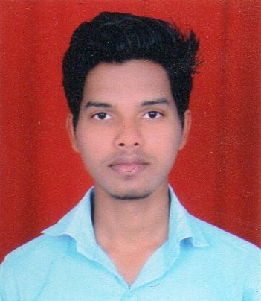
Akshay Moreshwar Patil
Mob No: 8087412400
Email ID: aksh4005@gmail.com

Career Objective:
I am looking for the challenging job, a job that gives me opportunities to learn and to continuously upgrade my knowledge and skills.

Personal Details:
Present Address : At. Varedi, Post. Hamarapur, Tal Pen,
Dist. Raigad, Pin Code- 402107.
Date of Birth : 02nd July 1997
Gender : Male
Marital status : Unmarried
Nationality : Indian
Languages Known : Marathi, Hindi and English

Educational Qualifications:
Education | University /Board | Year of Passing | Percentage | Class / Grade
S.S.C | Mumbai | March-2012 | 64.91 % | 1st Class
H.S.C | Mumbai | Feb – 2014 | 57.54 % | 2nd Class
Diploma in Mechanical Engineer | MSBTE | 2018 | 75.29% | 1st Class  Dist

Additional Qualifications:

- MS-CIT
- Tally

Work Experience:
- Fresher

Achievement
- JSW work in CMMD Dept. form 3rd June 2017 to 03rd July 2017

Other Activity:

- Third Year Project Dual Refrigeration System.
- State level Technical Quiz.

Behavior Profile:

- Co-Operative, Positive Attitude, Having Frank Nature.
- Interested In Doing New Ideas.
- Aggressive About Completion Of Work.

DECLARATION

I hereby declare that above information is true to the best of my knowledge and belief.
Date:
Place:
(Akshay Moreshwar Patil)

